

Requirement & Design Specification

Marathon Management
Version: 1.0

# | Member | MSSV | Role | Absent
1 | Mạc Đăng Hậu | HE171381 | Member
2 | Trần Tuấn Anh | HE182190 | Member

– Hanoi, January 2025 –
Contents
I. Overview 3
1.1. APIs 3
1.2. Diagrams 6
1.3. Models 9
1.4. Design 19
II. Detail Report 24
1. Analyze the problem 24
2. Features 24
3. Screen flow 26

I. Overview

1.1. APIs
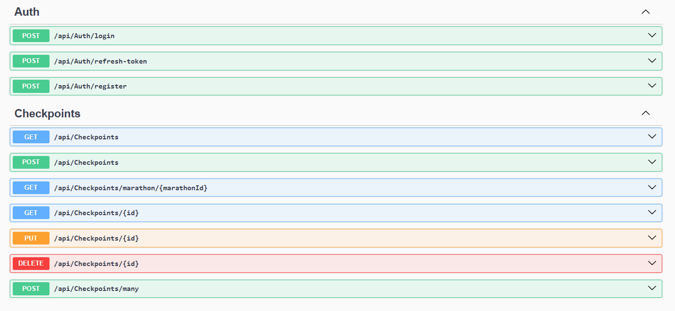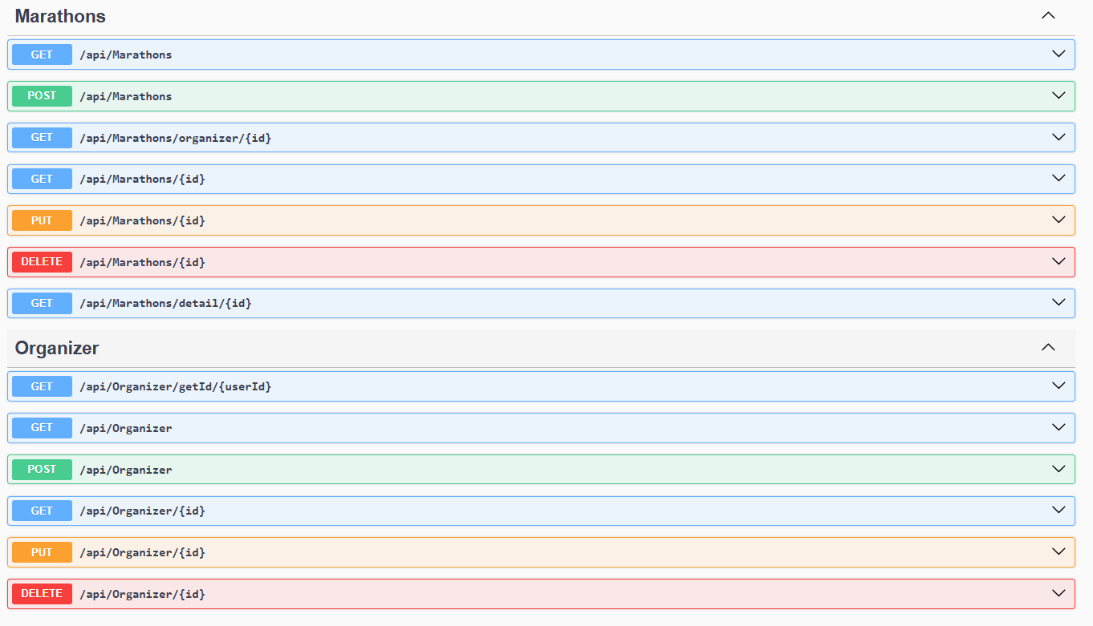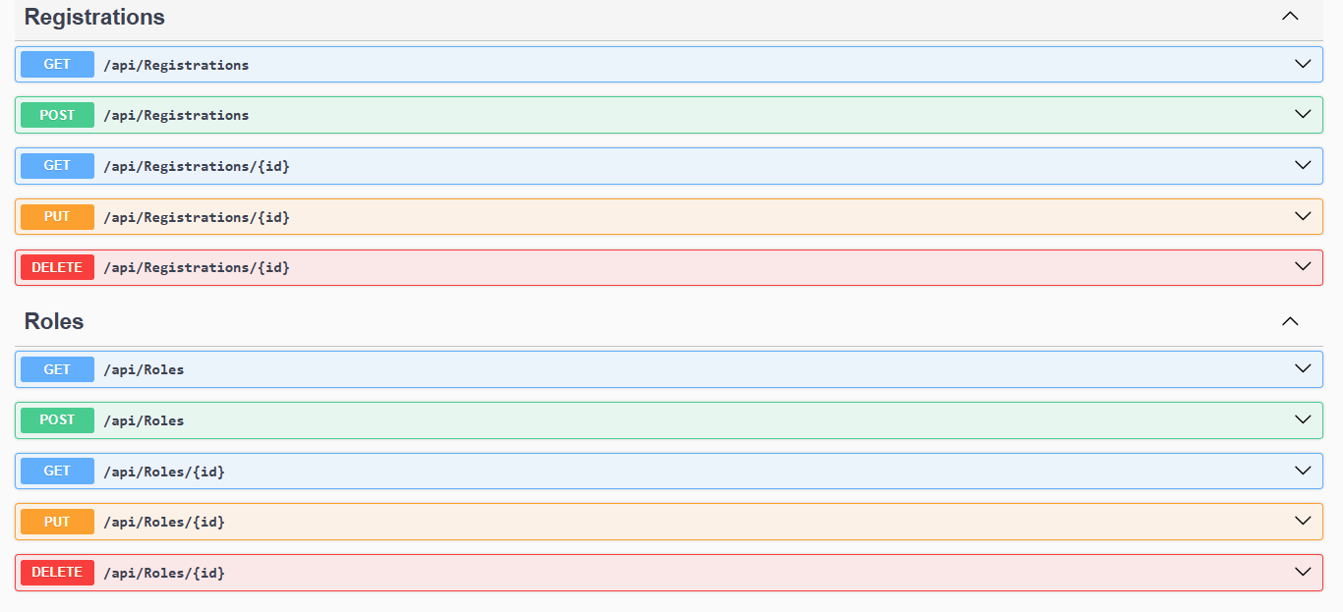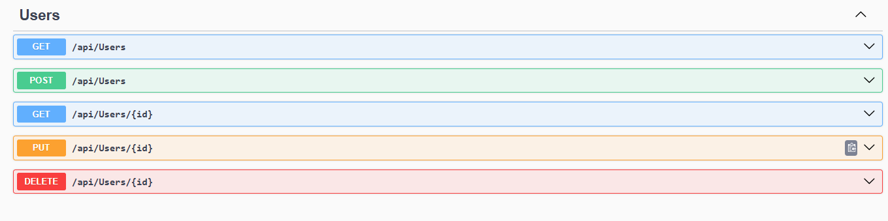

1.2. Diagrams
a. Context diagram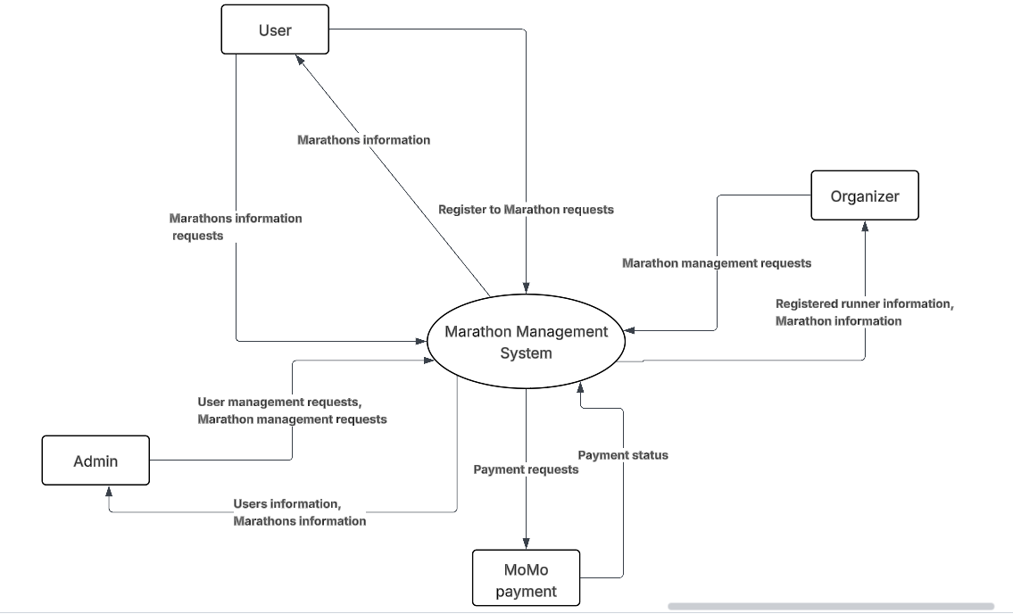

b. Use case diagram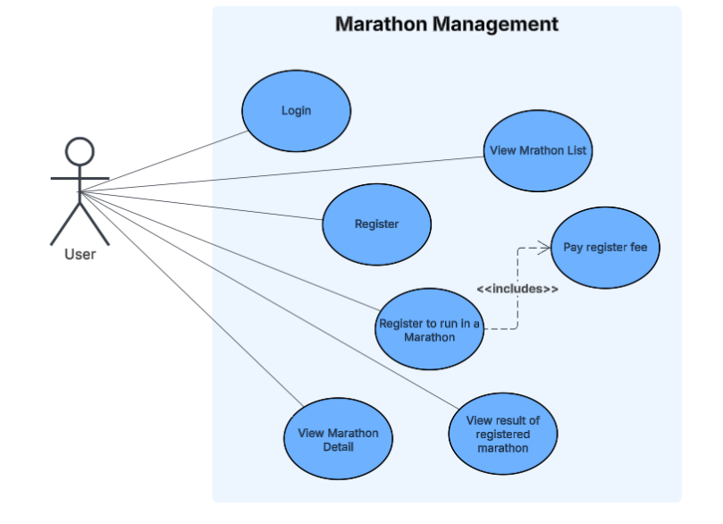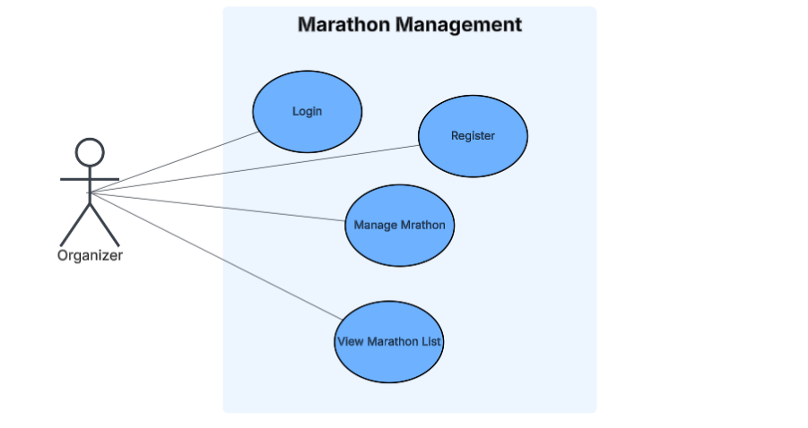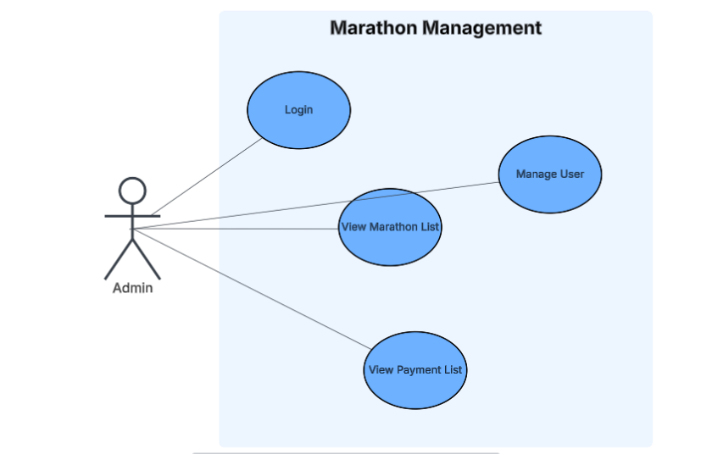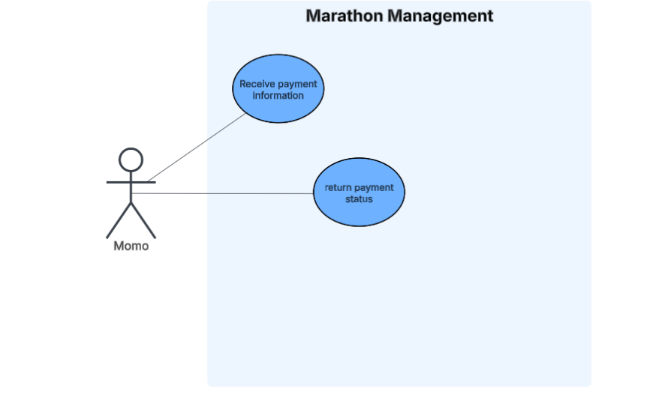

c. Actors
Actor | Description
Admin | The Admin is responsible for managing the system at a high level. This includes managing user accounts and overseeing marathons. Specifically, the Admin can view marathons and cancel them when necessary.
User | The User is a participant in the system. Users can browse and view available marathons and register to participate in marathons of their choice.
Organizer | The Organizer is responsible for creating and managing marathons. This includes creating new marathons, updating marathon details, and canceling marathons if required.
MoMo | MoMo represents the external payment service integrated into the system. It handles payment transactions for marathon registrations.

c. Database diagram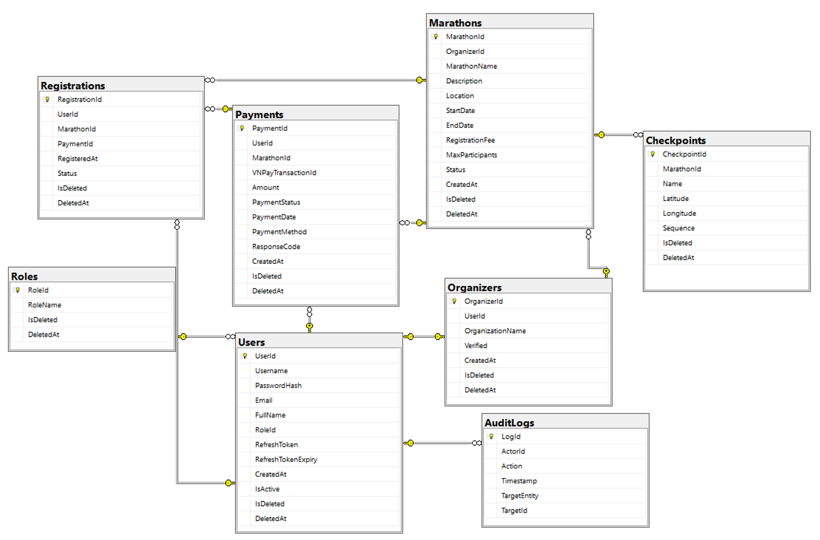

1.3. Models

a. Roles
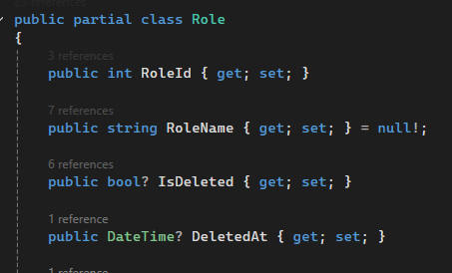

Property | Data Type | Description
RoleId | int | Unique identifier for the account.
RoleName | string | Stores the user's email address used for login.
IsDeleted | bool | Contains the hashed password of the user for authentication.
DeletedAt | DateTime | Stores the full name of the user.

b. User
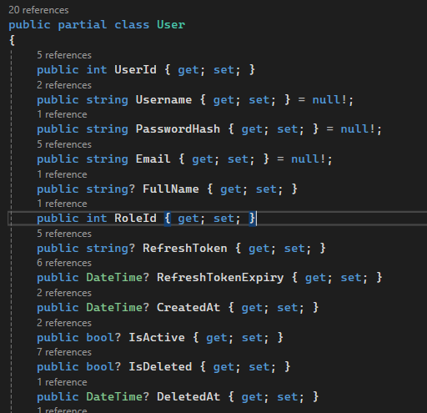

Property | Data Type | Description
UserId | int | Unique identifier for each activity record.
Username | string | Account name chosen by user
PasswordHash | int | Hashed password for authentication.
Email | string | User’s email address (unique).
FullName | string | User’s full name.
RoleId | int | Role assigned to the user.
RefreshToken | string | JWT refresh token for authentication.
RefreshTokenExpiry | DateTime | Expiration time for the refresh token.
CreatedAt | DateTime | Timestamp of account creation.
IsActive | bool | Whether the user account is active
IsDeleted | bool | Indicates if the user is soft-deleted.
DeletedAt | DateTime? | Timestamp when the user was deleted.

c. Organizers
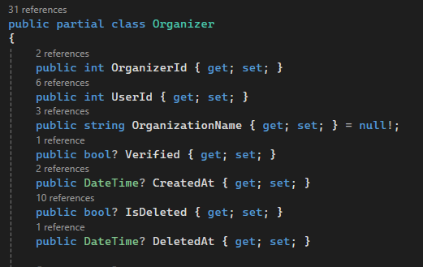
Property | Data Type | Description
OrganizerId | int | Unique identifier for the organizer.
UserId | int | Associated user account of the organizer.
OrganizationName | string | Name of the organizing company or group.
Verified | bool | Indicates if the organizer is verified.
CreatedAt | DateTime | Date and time the organizer profile was created.
IsDeleted | bool | Marks whether the record is soft-deleted.
DeletedAt | DateTime | Timestamp of deletion if applicable.

d. Marathons
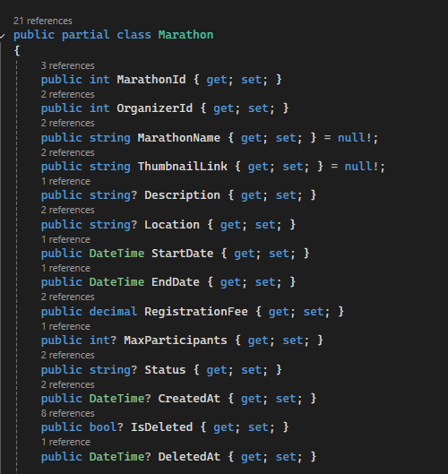
Property | Data Type | Description
MarathonId | int | Unique identifier for the marathon.
OrganizerId | int | Unique identifier for the marathon
MarathonName | string | Name of the marathon event
ThumbnailLink | string | URL to the marathon’s thumbnail image
Description | string | Detailed information about the marathon
Location | string | Location where the marathon takes place
StartDate | DateTime | Start date and time of the marathon
EndDate | DateTime | End date and time of the marathon
RegistrationFee | decimal | Entry fee for participants
MaxParticipants | int | Maximum allowed participants
Status | string | Current status (e.g., Upcoming, Ongoing, Completed)
CreatedAt | DateTime | Creation timestamp
IsDeleted | bool | Indicates soft deletion
DeletedAt | DateTime | Timestamp when deleted

e. Checkpoints
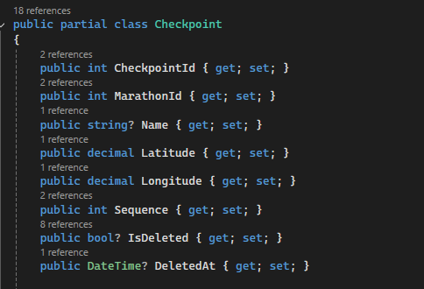
Property | Data Type | Description
CheckpointId | int | Unique identifier for each registration record.
MarathonId | int | Associated marathon
Name | string | Name or label of the checkpoint
Latitude | decimal | GPS latitude coordinate
Longitude | decimal | GPS latitude coordinate
Sequence | int | Order of checkpoints along the route
IsDeleted | bool | Indicates if the checkpoint is soft-deleted
DeletedAt | DateTime | Timestamp of deletion

f. Registration
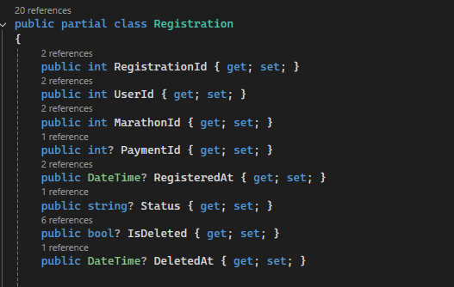
Property | Data Type | Description
RegistrationId | int | Unique identifier for registration
UserId | string | Registered user
MarathonId | int | Marathon being registered for
PaymentId | int | Linked payment record if available
RegisteredAt | DateTime | Date and time of registration
Status | string | Registration status (Pending, Confirmed, Cancelled)
IsDeleted | bool | Marks if the record is soft-deleted
DeletedAt | DateTime | Timestamp when deleted

g. Payments
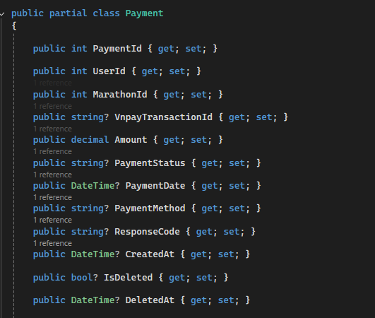
Property | Data Type | Description
PaymentId | int | Unique identifier for the payment record
UserId | int | User who made the payment
MarathonId | string | Related marathon event
VNPayTransactionId | decimal | Transaction ID from VNPay or MoMo gateway
Amount | Event | Amount paid
PaymentStatus | string | Payment status (Pending, Completed, Failed)
PaymentDate | DateTime | Date and time of payment
PaymentMethod | string | Method used (default: MoMo)
ResponseCode | string | Response code from payment provider
CreatedAt | DateTime | Record creation timestamp
IsDeleted | bool | oft delete flag
DeletedAt | DateTime | Deletion timestamp

h. AuditLogs
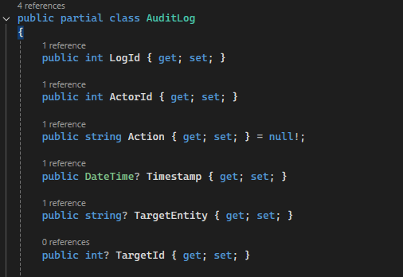
Property | Data Type | Description
LogId | int | Unique identifier for each log entry
ActorId | int | User who performed the action
Action | string | Description of the action taken
Timestamp | DateTime | Date and time of the logged action
TargetEntity | string | The entity/table affected by the action
TargetId | int | ID of the affected entity record

1.4. Design

1.4.1. Login page
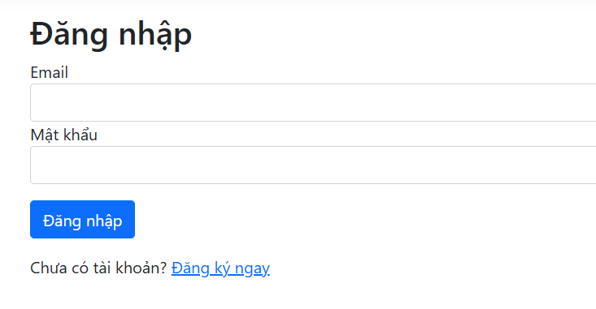

1.4.2. Register page
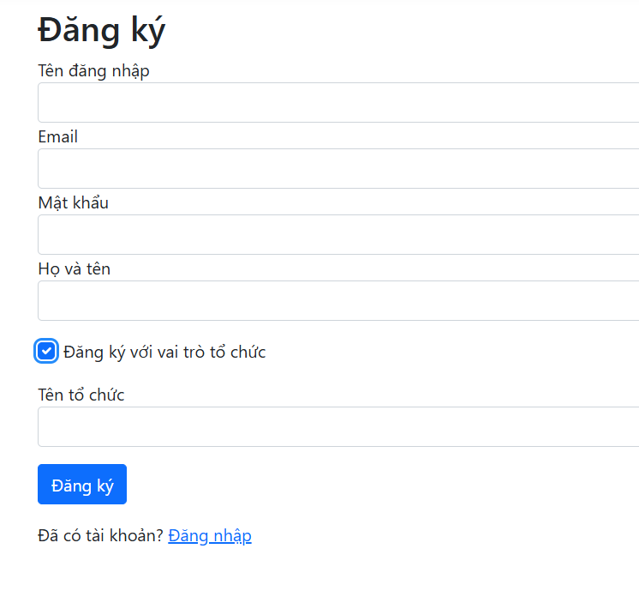

1.4.3. Homepage
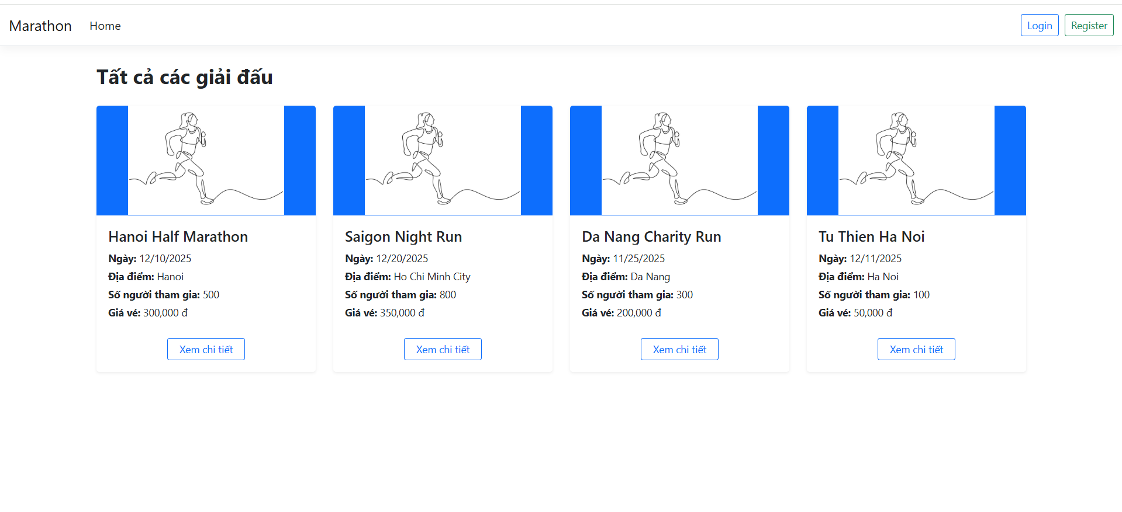1.4.4. Marathon detail page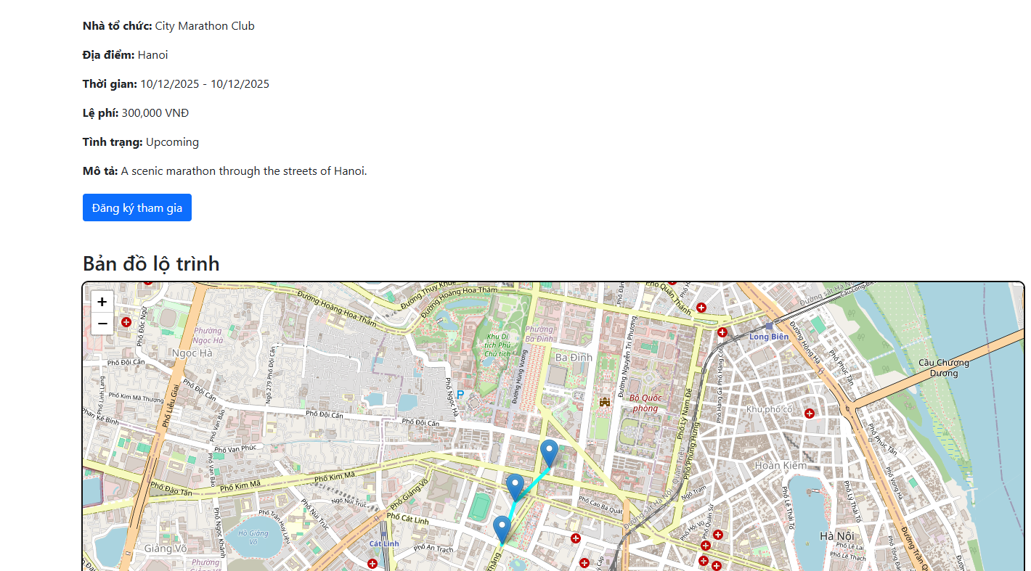

1.4.5. Organizer Homepage
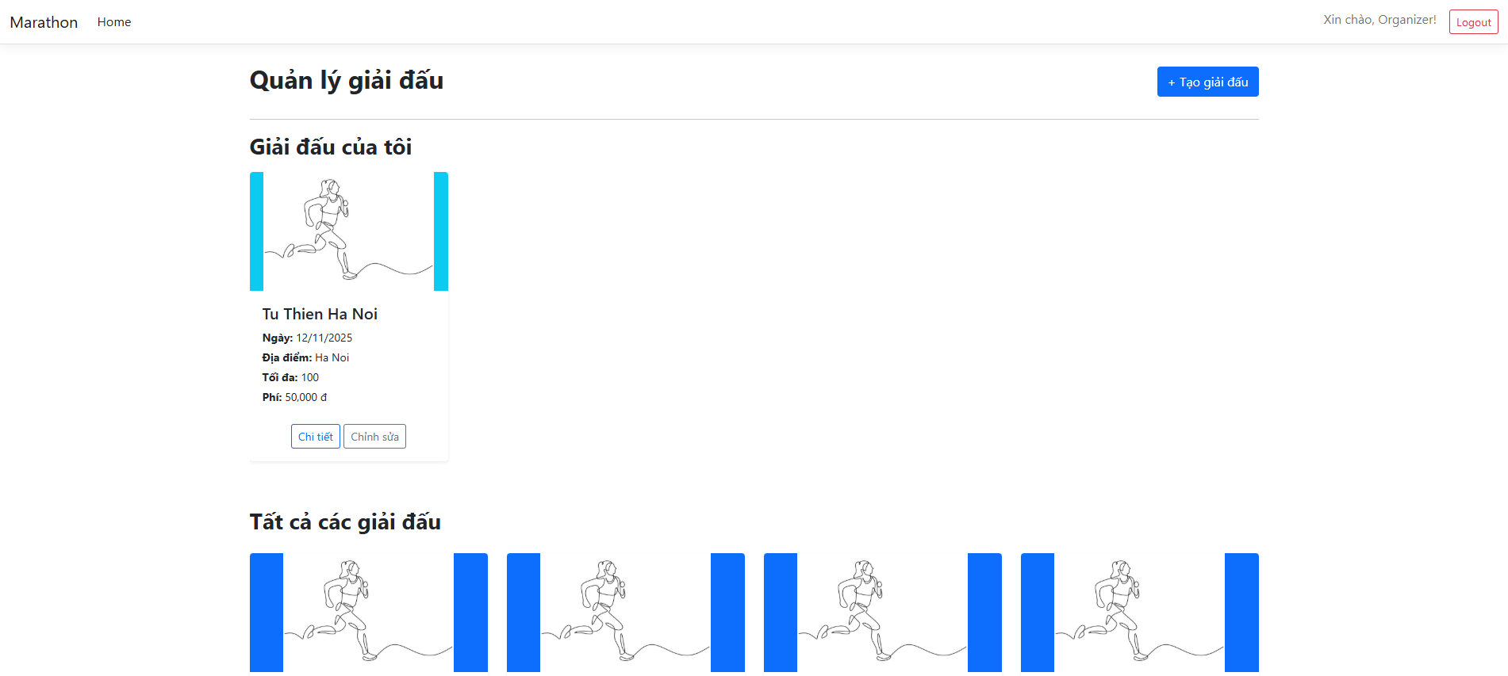

1.4.6. Create Marathon page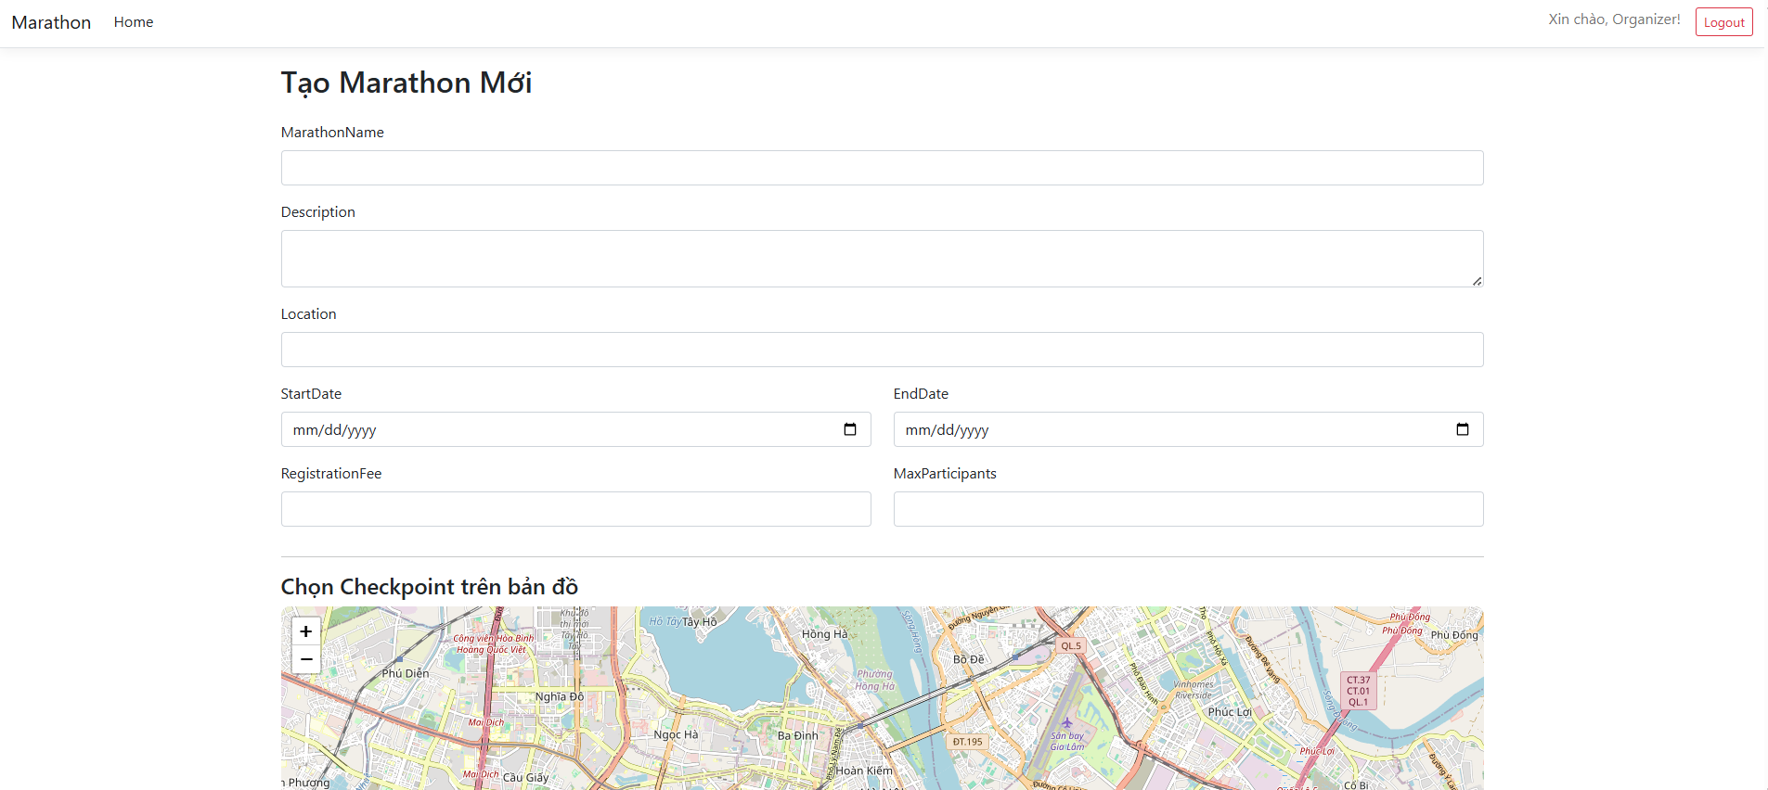

1.4.7. Manage User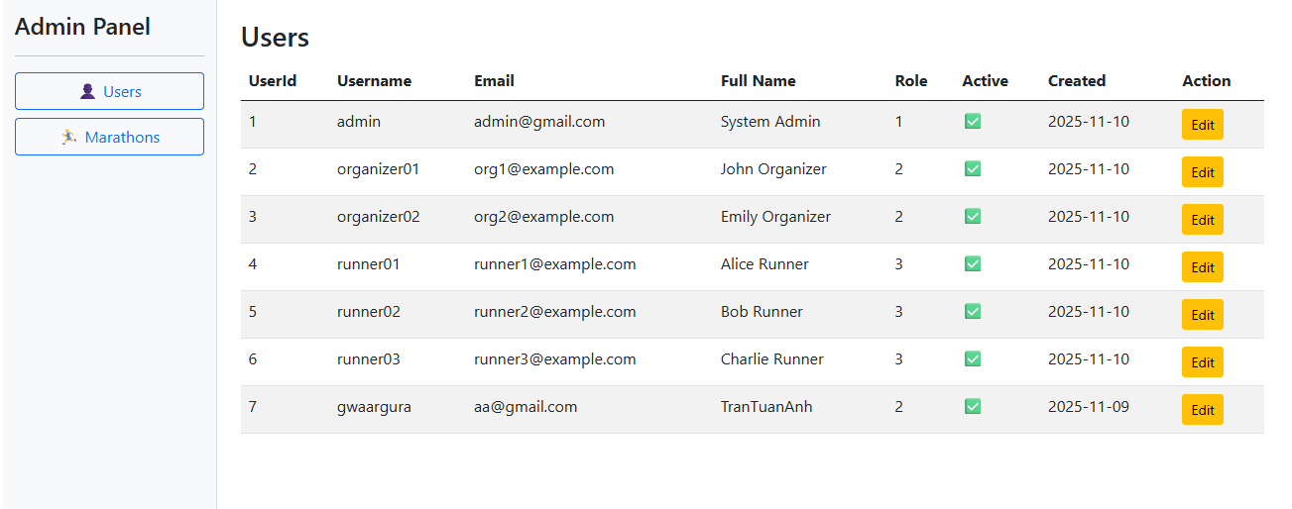

1.2.8. Manager Marathon
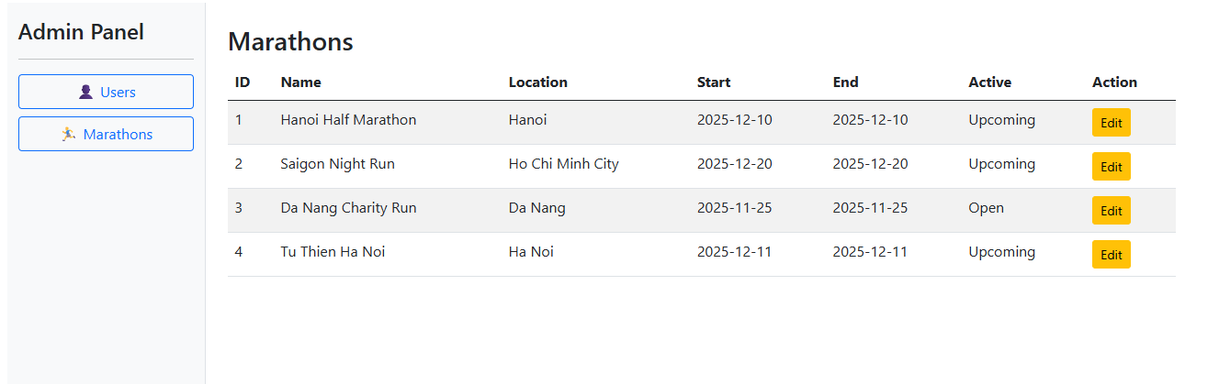

II. Detail Report

1. Analyze the problem
Managing marathon events manually often leads to inefficiencies such as data loss, registration errors, and poor tracking of participants’ performance. Organizers struggle to handle participant information, event schedules, and race results in an organized and centralized way. Participants also face difficulties registering, monitoring their progress, and viewing results conveniently.
The Marathon Management System aims to solve these issues by providing a digital platform that connects organizers and runners. It allows event creation, user registration, performance tracking, and result management efficiently and securely.

2. Features
No | Feature | Role | Description
01 | User | Registration and Authentication | User Users can create accounts, log in securely, and access personalized marathon features.
02 | Marathon Management | Admin/Organizer | Organizers can create, update, and manage marathon events with details such as name, date, duration, and registration fee.
03 | Participant Registration | User | Users can register for marathon events and receive confirmation of successful registration.
04 | Activity Tracking | User | Runners can record running activities, including distance, duration, and average pace.
05 | Performance Statistics | User | Users can view their total running distance, pace history, and performance over time.
06 | Checkpoint Management | Organizer | Organizers can create and manage route checkpoints (e.g., 5km, 10km, Finish Line) for each marathon event.
07 | Role-based Access Control | Admin | Admins can assign roles (Admin, Organizer, Runner) with appropriate permissions.  .
08 | Event Registration Management | Organizer | Organizers can view participant lists, approve or cancel registrations, and manage event capacity.
09 | Result Management | Organizer | Organizers can update and publish event results or leaderboards.
10 | User Profile Management | User | Users can update their personal information such as full name, gender, address, and profile picture
11 | Event Search and Filtering | User | Users can search for events by name, organizer, or date and filter based on categories (e.g., Marathon, Half Marathon).
12 . | Notifications System | User | Users receive notifications about registration updates, event changes, and upcoming marathons.
13 | Organizer Management | Admin | Admins can manage organizer information including organization name, contact email, and website.
14 | Security Features | System | Implements secure authentication using JWT, password hashing, and refresh tokens.
15 | API Documentation | System | The system provides comprehensive API documentation using Swagger/OpenAPI for developers.
16 | Error Handling and Logging | System | Implements structured error responses and logging for debugging and monitoring.
17 | Performance Optimization | System | Utilizes caching and optimized database queries to enhance performance and scalability

3. Screen flow
